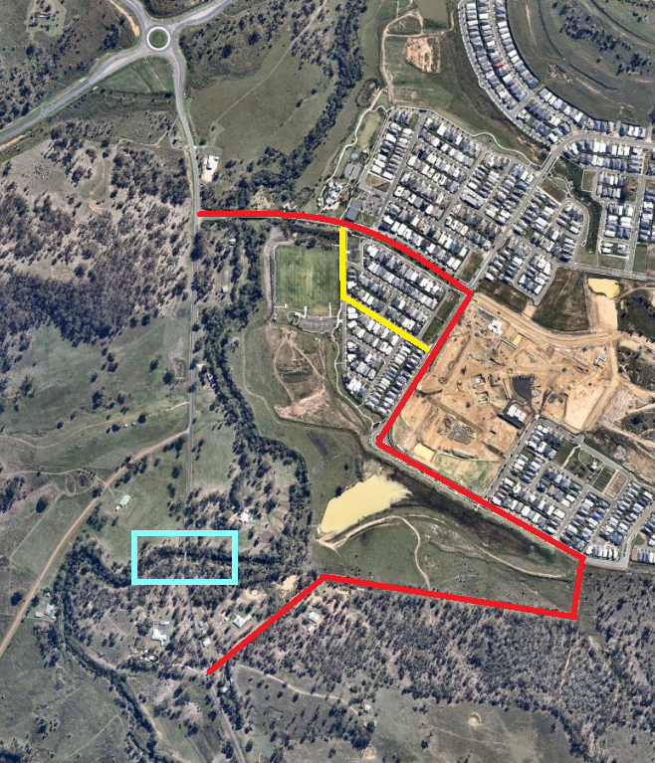

Council Detour

**Legend**

Secondary Detour (short term)

**Drive**

**Splendid**

**Ripley Road**

**Bayliss Road**

**Bayliss Road**

**Bayliss Road**

**Parkway Avenue**

**Parkway Avenue**

**Location of   
Ripley Road Timber Bridge**

**Road**

**Watsons**

**Parade**

**Providence Parade**

**Ripley Road**

**Ripley Road**