Ipswich Open Prize Meet
29 July 2018
8.45 am
Ripley Rifle Range, 1494 Ripley Road South Ripley

Range Trophies, Aggregate Trophies and Badges sponsored by:
Australia’s Camping Quartermaster - DC Locators - Harding Martin Financial Services Ipswich City Council – Jim Rush Shooting Supplies – Qld Rifle Association
$45 entry for all grades and classes  Complimentary gift | Badges and prize money  in all Grades and Classes
10 Shot matches  600,600 and 800m  Aggregate Trophies  Range Trophies  Prize money | 1st - Badge & $150 & Trophy  2nd - Badge & $75  3rd - Badge & $50  4th - Badge & $25  5th - Badge & $25  A grade badges to 10th place
The Jim Rush Memorial - Gold Bullion Badges for the top Ipswich member in
A, B & C Grade - F Standard A & B - F Open - F TR
Every entry receives a complimentary $5 ticket in the draw for The QRA Q Store Voucher
and a WEAVER T Series XR Target Scope, 46 X 48, 30mm tube.
Tickets are also available for sale.
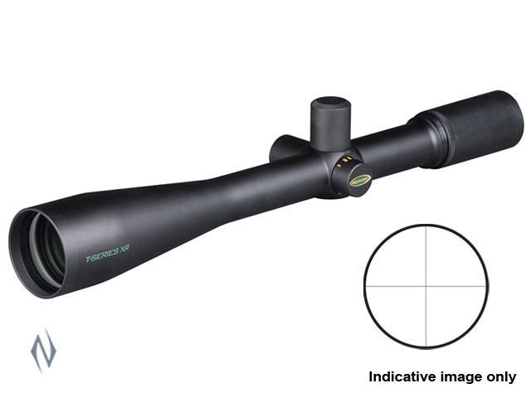
Weaver’s new T series XR fixed power riflescopes combine legendary
T-series target scope performance with an all-new side focus parallax
adjustment system. No matter how far off-centre the shooter’s eyepiece-to-eye alignment, the point of impact will remain true. These argon-purged scopes feature the incredibly-precise Micro-Trac Adjustment system for competition-level, completely independent windage and elevation control with 1/8th-inch
click values. The fully multi-coated optics offer superior contrast, eliminate glare
and deliver professional-grade clarity.
https://acqm.com.au/ | https://www.511tactical.com.au/

