Media Release: 04/12/2014

The appointment of Ipswich City Council as trustee of the Old Redbank Rifle Range site comes as welcome news.

Historically the site, a nature corridor situated between Redbank and Goodna, served as a major training ground for Australian and US military forces during World War Two. It also provided a home range for generations of Ipswich and District Rifle Club members and those of its predecessor clubs including the Ipswich Railway Rifle Club and Ipswich City Rifle Club.

Under the Defence Act 1903, The Commonwealth developed Rifle Ranges throughout Australia to assist in creating a ‘civilian based’ reserve defence force. Civilians joined the ranks and pledged an Oath to the Commonwealth.

As a result the sport of competitive target shooting soon flourished. The Redbank Rifle Range was the venue of many national competitions for the competitive target shooters of Ipswich and its surrounds. Former A Grade club champion Jim Rush recalls fondly of many long days of competition spent on the Redbank Rifle Range. He states that the highlights of the year were always both the club and district prize meetings.

A large contingent of the members of Ipswich based Rifle Club’s enlisted in both World War One and World War Two. A number of its members were killed in both conflicts. Including Sapper James Archibald Lindsay of the Redbank Railway Rifle Club killed in action, Gallipoli, 10th May 1915 along with fellow club members and brothers, Pvt. Alexander James Lindsay and Pvt. Edgar Ronald Lindsay. The Lindsay’s were one of five sets of brothers in Ipswich to serve and die during the Great War. Alexander killed in action, Belgium, 20th September 1917. Edgar killed in action, France, 5th July 1918.

The Redbank Rifle Range was in operation 1912 – 1980. At its peak the target gallery consisted of 20 targets with multiple Firing mounds situated from 200 yards to 700 yards away from the line of targets. The 700 yard firing mound was situated approximately 35 Meters across a paddock from the Redbank Train Station, however, with the construction of the Ipswich Motorway in the 1960’s the range template was reduced and limited to firing at a distance of 500 yards. At the time the firing line at 500 yards was situated right on the southern fence line of the Ipswich Motorway as it sits today.

Whilst officially decommissioned in 1982 by the Australian Defence Force, the Redbank Rifle Range had been vacated several years prior by the thriving Ipswich and District Rifle Club. In the late 1970s the club secured tenure on a suitable site at South Ripley where it still meets every Saturday to continue the long tradition of competitive target shooting in Ipswich and it’s surrounds.

The Old Redbank Rifle Range will forever be held in high regard as a site integral to the development of our nation’s defence force. Perhaps most sentimentally to locals of the region it will always remain known as the Old Redbank Rifle Range a home for national champions and the site where a volunteer club made a name for itself in an international sport.

The Ipswich and District Rifle Club is hopeful that future development on the site will recognise the historical significance of the Redbank Rifle Range to its members, their history and the wider Ipswich community.

The last shots on Redbank’s 400mtr firing mound
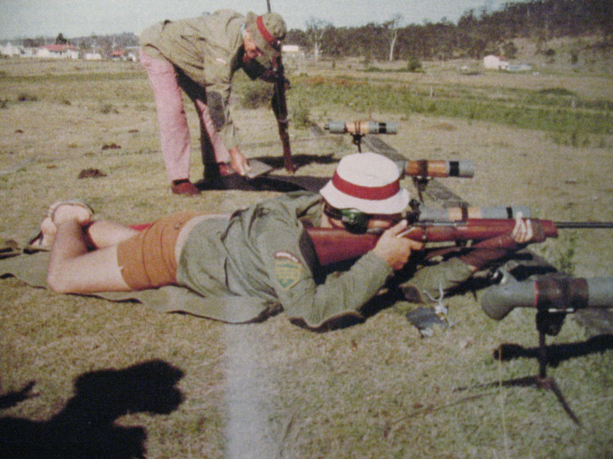

400 meter firing mound of the Old Redbank Rifle Range pictured during upgrades to the Ipswich Motorway circa 2012.
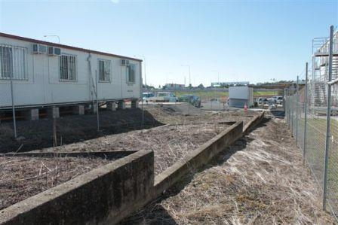
Sub note: Ipswich is home to the oldest Rifle Club in Queensland, with the Ipswich Rifle Club having formed in 1859.

Media enquires: Club Captain Glenn Rush idrc@live.com.au

